【产品教程】-基础 2025.08.12 VOLT Basic Environment Setup
Operational Background:
The WAN port of the router is connected to the operator's network, while the LAN port of the router is connected to the main port of the switch. A VOLT (presumably referring to a specific type of optical network terminal or interface) is plugged into a downstream optical port of the switch. Below the VOLT optical port lies a PON (Passive Optical Network). Fiber optic cables are then used to connect from this PON to the main port of a fiber optic splitter. The splitter distributes the fiber optic connections down to optical APs (Access Points) in individual rooms. The wireless networks provided by these optical APs support wireless devices such as mobile phones and wireless speakers, while the wired networks from the optical APs support devices like televisions and computers.
In this entire network setup, the LAN port of the router serves as the exit point for the local area network. Corresponding VLAN sub-interfaces are created to act as gateways for each virtual local area network below, as illustrated in the following diagram (note: the diagram is mentioned but not provided in the text).
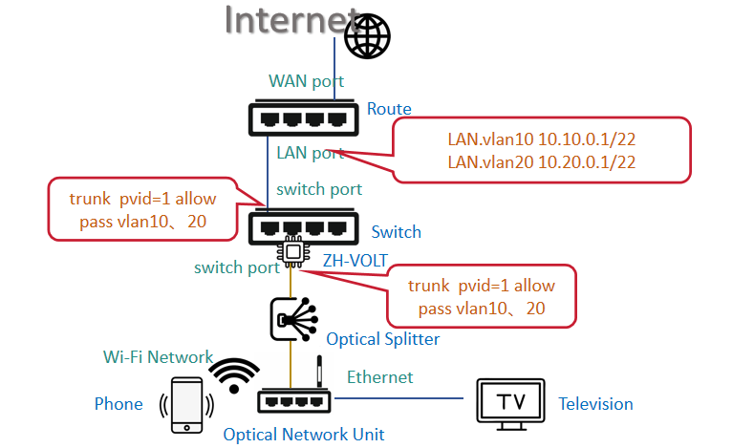
1. Configuration and Debugging Process
Step 1: Configure core network devices such as routers and switches
(1) Connect the devices according to the aforementioned networking requirements.
(2) Configure VLAN sub-interfaces and enable DHCP
Configure VLAN sub-interfaces on the router and assign IP addresses to these interfaces to serve as the exit gateways for the underlying virtual local area networks. Additionally, enable DHCP on the corresponding VLAN sub-interfaces to distribute IP addresses to terminal devices within these virtual local area networks.
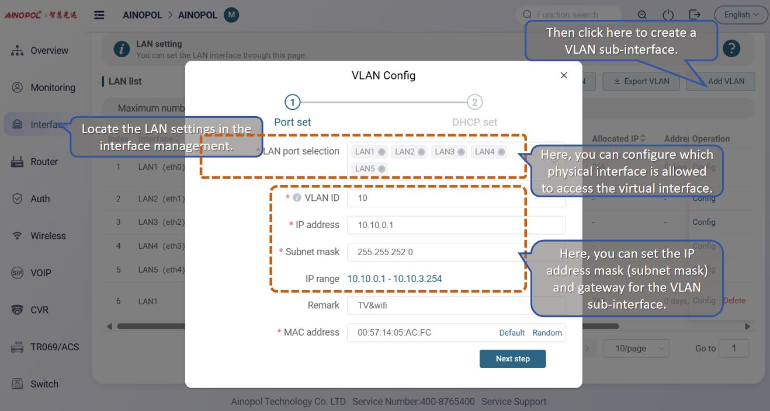
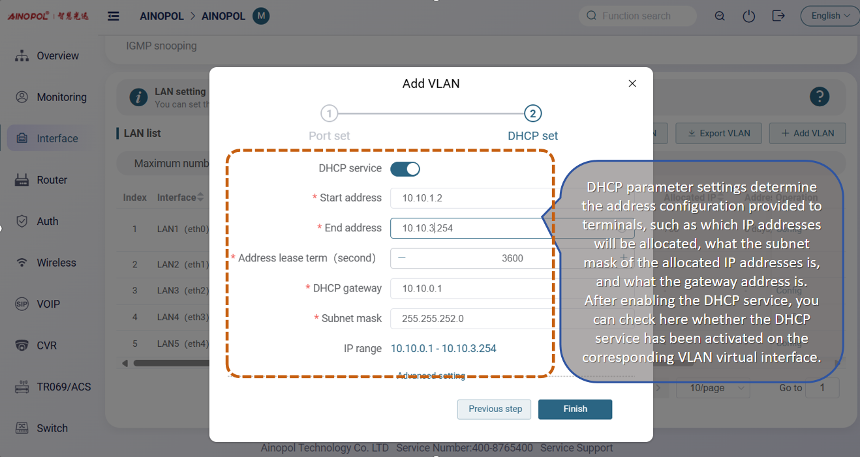
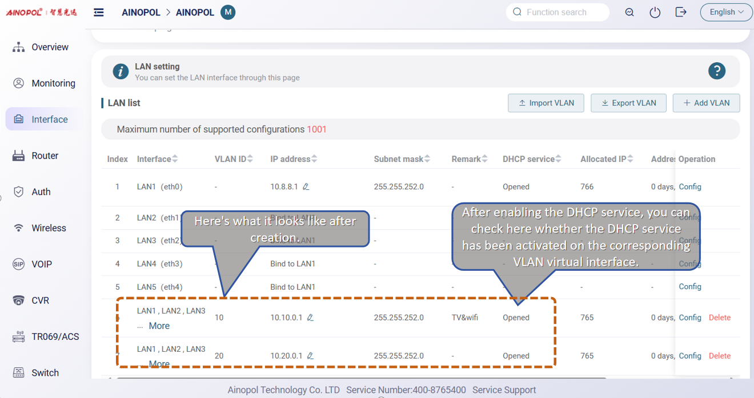
(3) Enforce port speed on the switch
Force the port speed to Gigabit on the switch port that connects to the VOLT device, while no speed enforcement is needed for the main port.
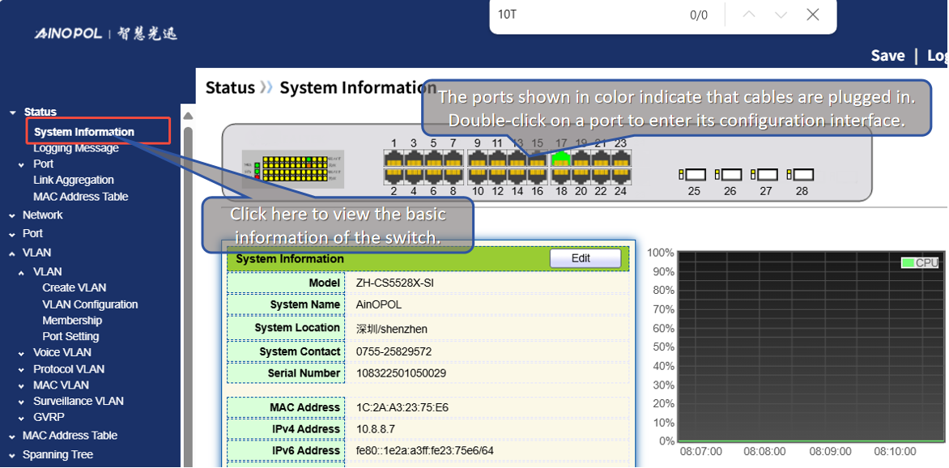
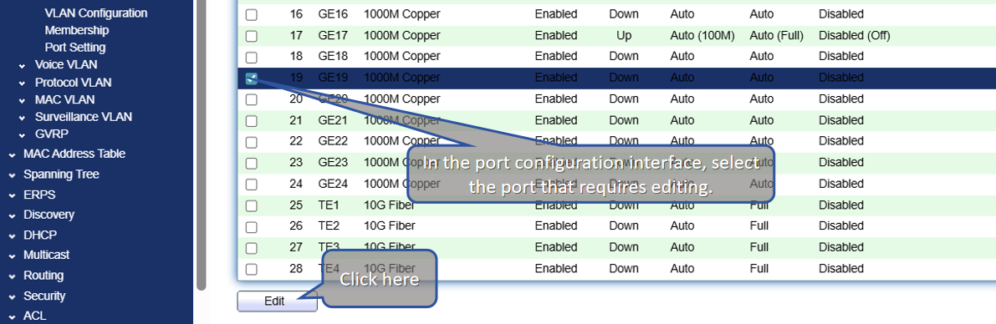
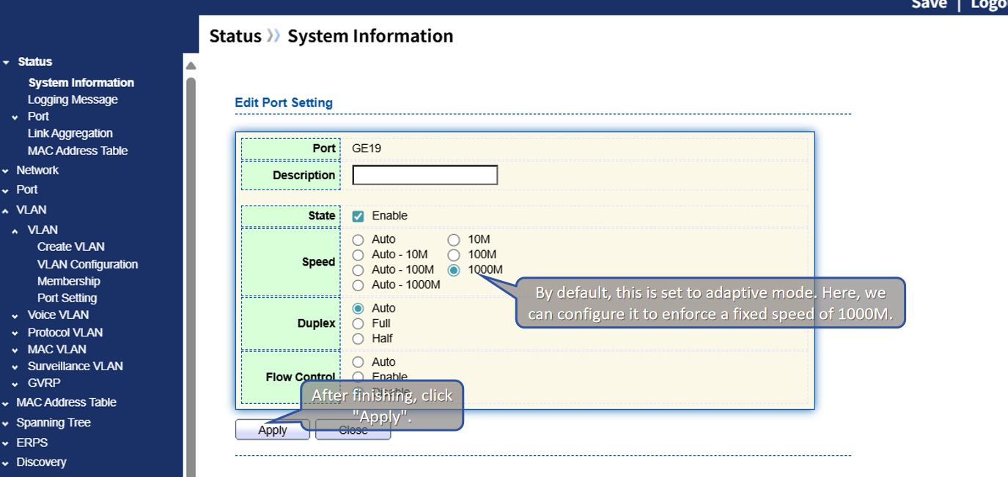
(4) Allow corresponding VLANs on the switch
Our switch is set to fully transparent transmission by default. However, since the VOLT is connected to the corresponding optical port on the switch, we need to explicitly allow the relevant VLANs; otherwise, the downstream optical modem will not be able to obtain an IP address.
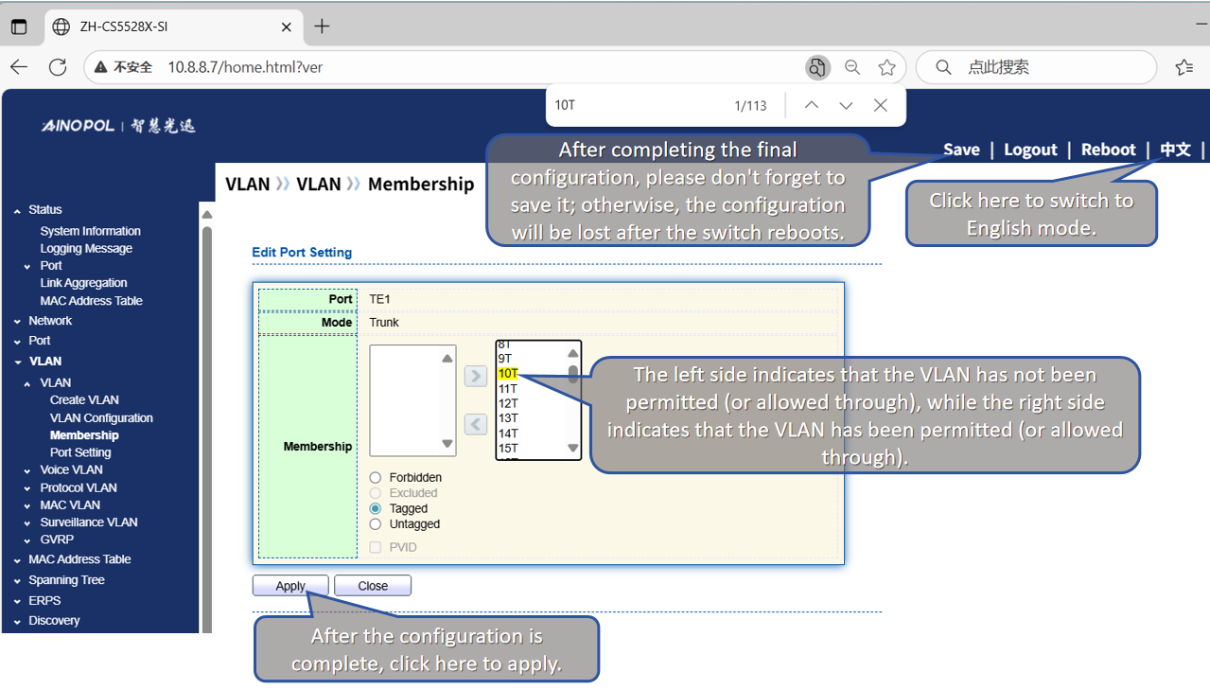
Step Two: Debugging Terminal Devices
(1) Check and confirm whether the indicator lights on the ONU (Optical Network Unit) are functioning normally. Under normal circumstances:
Normal Indicator Light Status:
The optical signal light is off, and the registration light is steadily on.
Abnormal Indicator Light Status 1:
The optical signal light is off, but the registration light is flashing. In this case, further checks are required:
A. Verify whether the ONU supports the GPON protocol.
B. Check if the received optical power at the ONU end is within the range of -15dbm to -25dbm.
C. Investigate whether there are any issues with the optical splitter.
Abnormal Indicator Light Status 2:
The optical signal light is red, indicating that the ONU is not receiving any optical signal. Further checks are necessary:
A. Use an optical power meter to directly connect to the VOLT (presumably a typo and should be OLT - Optical Line Terminal, or confirm if VOLT refers to a specific device here) to check if it is emitting light normally.
B. Use an optical power meter to test along the optical link to determine at which point the optical signal is lost.
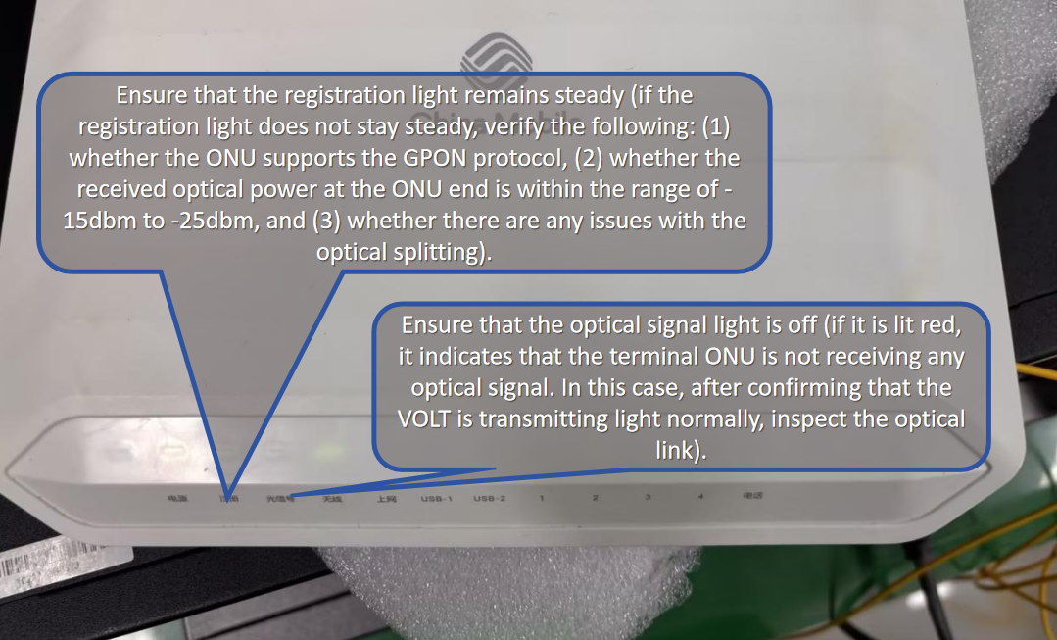
(2) Create a WAN connection on the optical modem (ONT/ONU) and bind the corresponding port(s) of the optical modem for use by different services.


